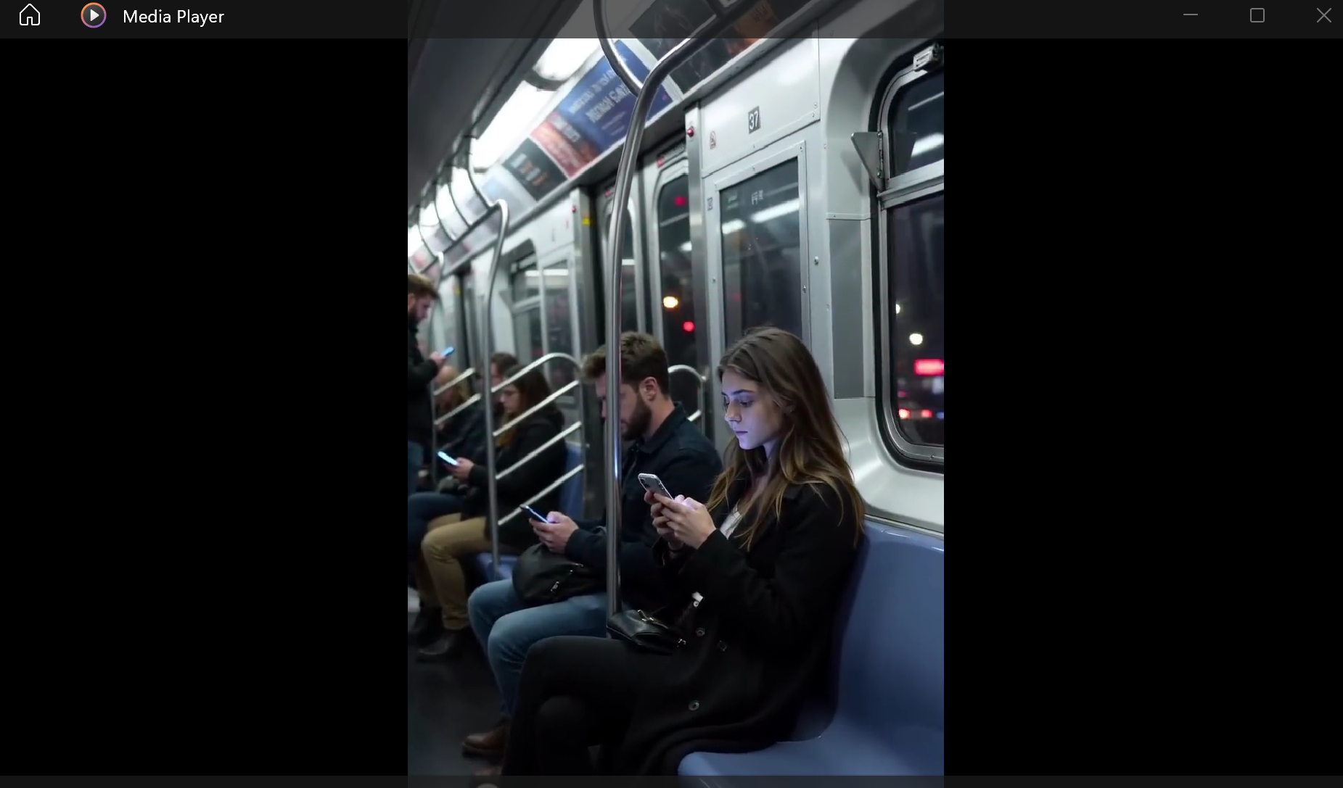
Video of “modern city train at night, crowded environment, people scrolling endlessly on smartphones, blue screen glow illuminating tired faces, cinematic realistic lighting, emotional atmosphere, subtle handheld camera movement”
“夜晚的现代城市列车车厢，拥挤的环境，人们不断地刷着智能手机，蓝色屏幕光照亮疲惫的脸庞，电影感写实灯光，带有情绪张力的氛围，轻微的手持镜头晃动。”
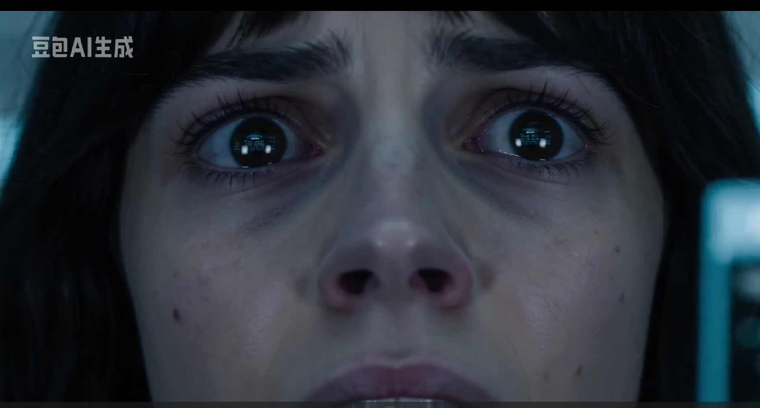
16:9 video of young woman overwhelmed by endless notifications and social media content, fast-paced digital overload, holographic UI fragments surrounding her, emotionally exhausted atmosphere, cinematic futuristic realism
“生成一段 16:9 的视频：一位年轻女性被无尽的通知和社交媒体内容压得喘不过气，快节奏的数字信息过载，全息 UI 碎片环绕在她周围，整体氛围体现出情绪上的疲惫与压迫感，电影感的未来主义写实风格。”
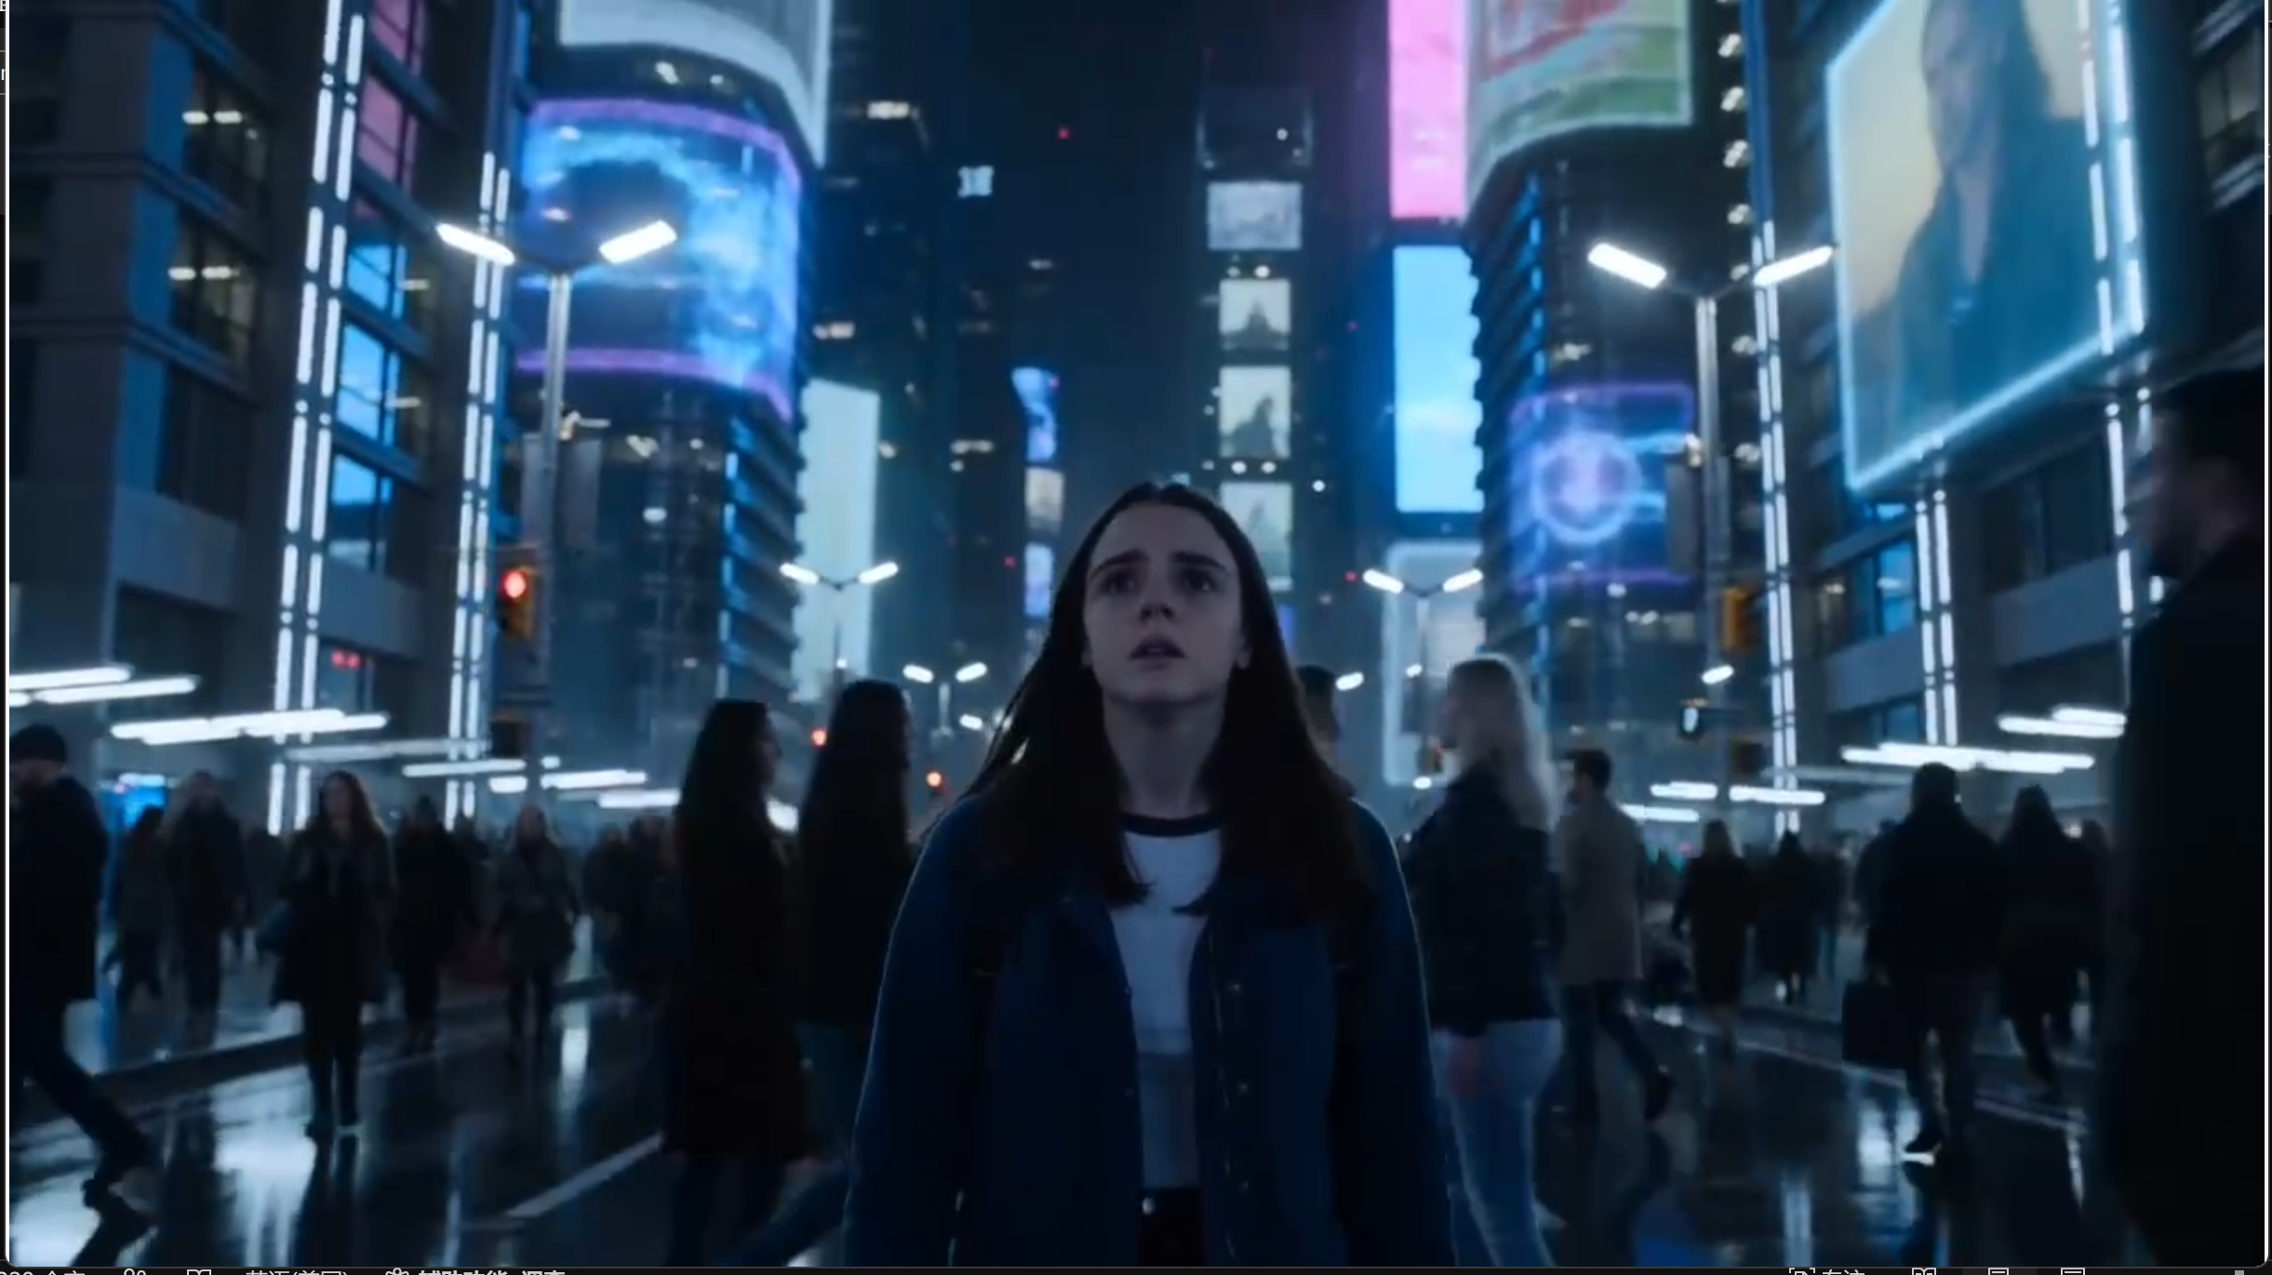
“cinematic transition from present-day world into the year 2070, futuristic architecture emerging, holographic advertisements floating through the city, sleek transportation systems, immersive premium sci-fi realism, emotional and hopeful atmosphere”
“从现代世界以电影感十足的方式过渡到 2070 年，未来主义建筑逐渐显现，城市中漂浮着全息广告，流线型交通系统穿梭其中，沉浸式、高端的科幻写实风格，充满情感并带有希望感的氛围。”
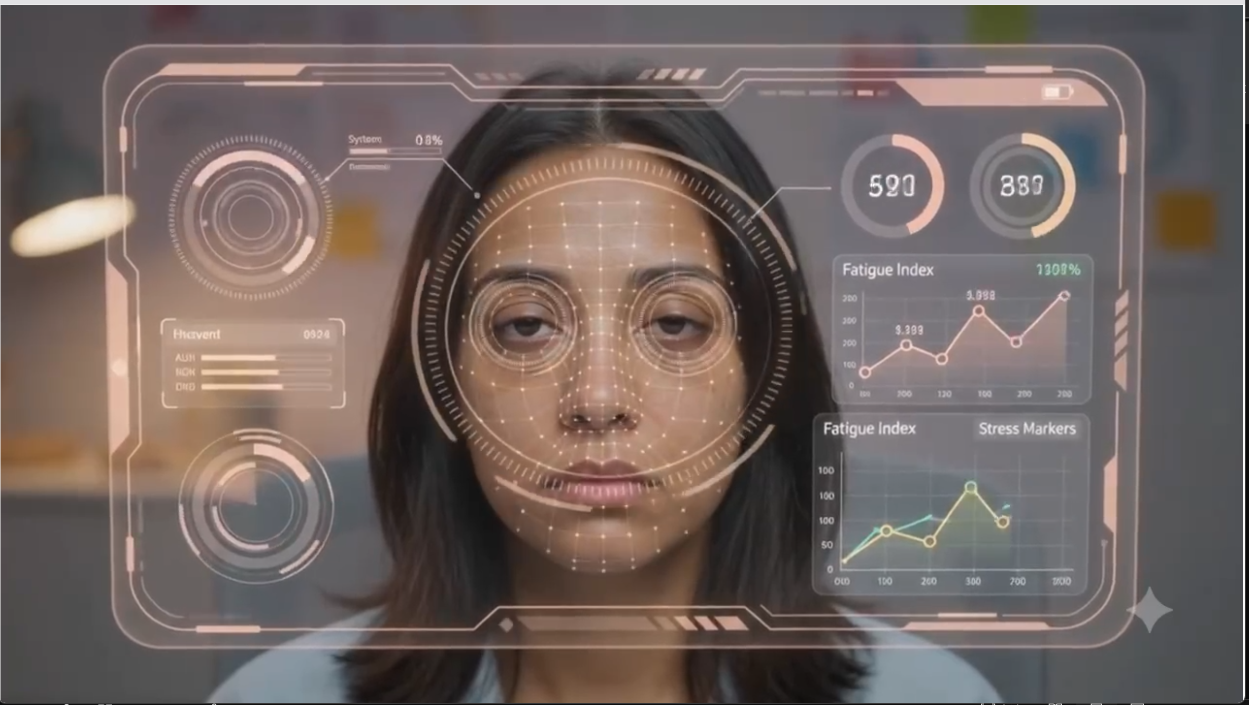
Close-up of futuristic smartphone camera interface analyzing the user’s emotional state in real time, subtle holographic UI elements, calm ambient glow, emotionally intelligent AI system detecting stress and fatigue, cinematic futuristic realism
“未来感智能手机相机界面的特写，实时分析用户的情绪状态，带有细微的全息 UI 元素，柔和宁静的环境光，具备情感智能的 AI 系统正在检测压力与疲劳，电影感的未来主义写实风格。”
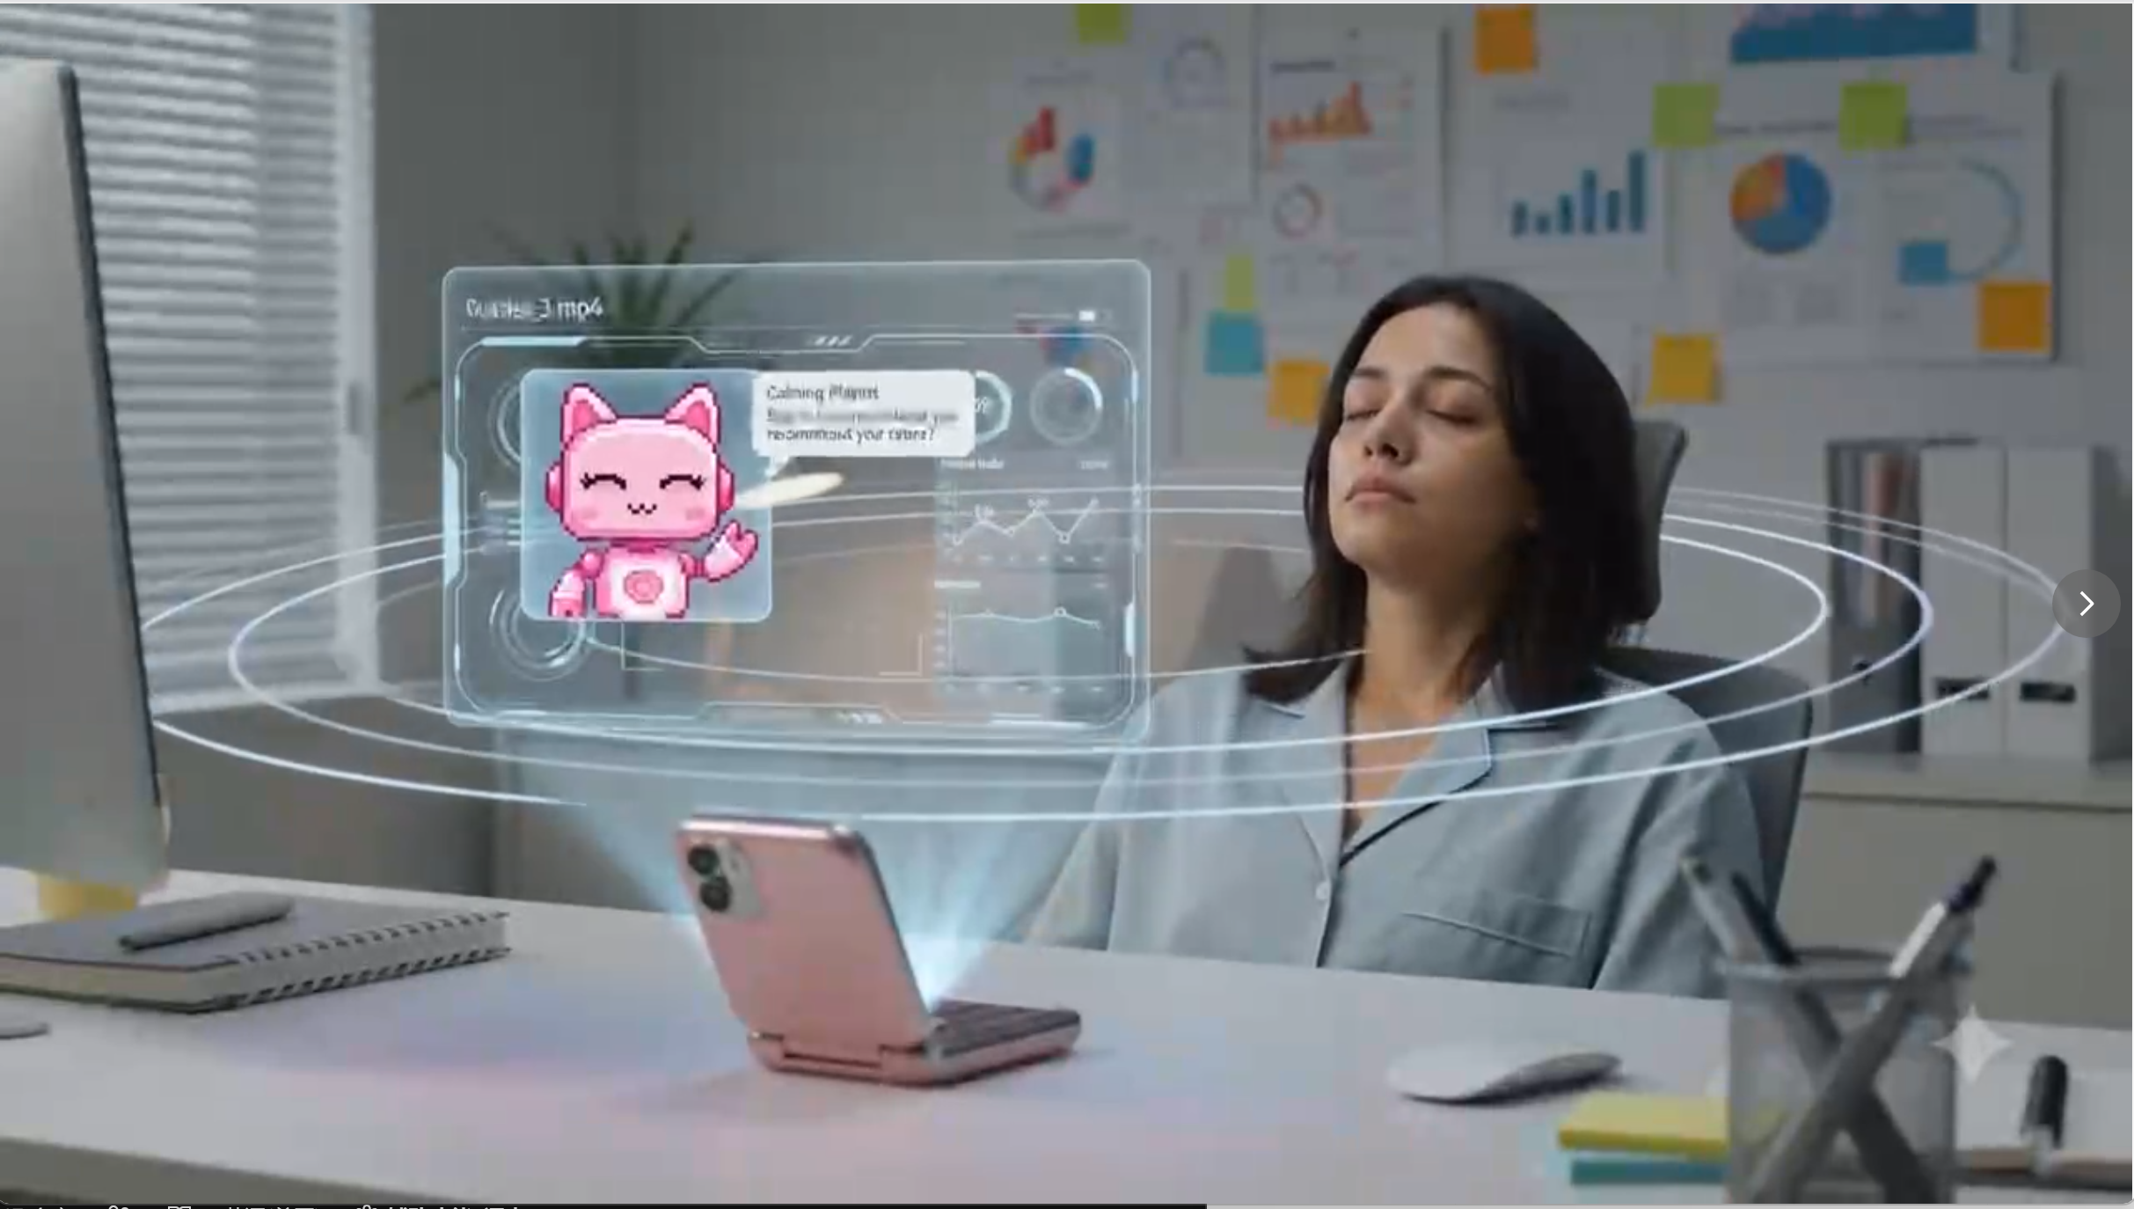
Futuristic AI camera interface automatically simplifying notifications, dimming distracting visuals, adjusting environment lighting and audio recommendations, calming holographic visuals surrounding the user, human-centered future technology
“未来感 AI 相机界面自动简化通知内容，调暗容易分散注意力的视觉元素，并根据用户状态调整环境灯光和音频推荐；平静柔和的全息视觉效果环绕在用户周围，展现以人为中心的未来科技。”
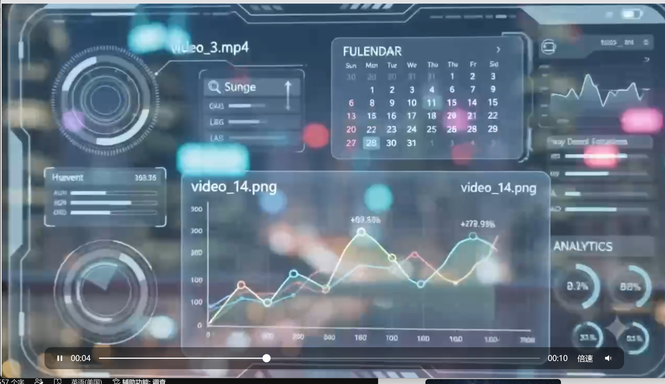
Cinematic futuristic city skyline at night, holographic interface softly glowing around the user, emotional and hopeful atmosphere, elegant sci-fi realism, premium future technology aesthetic
“电影感十足的未来城市夜景天际线，柔和发光的全息界面环绕在用户周围，充满情感与希望感的氛围，优雅的科幻写实风格，高端未来科技美学。”
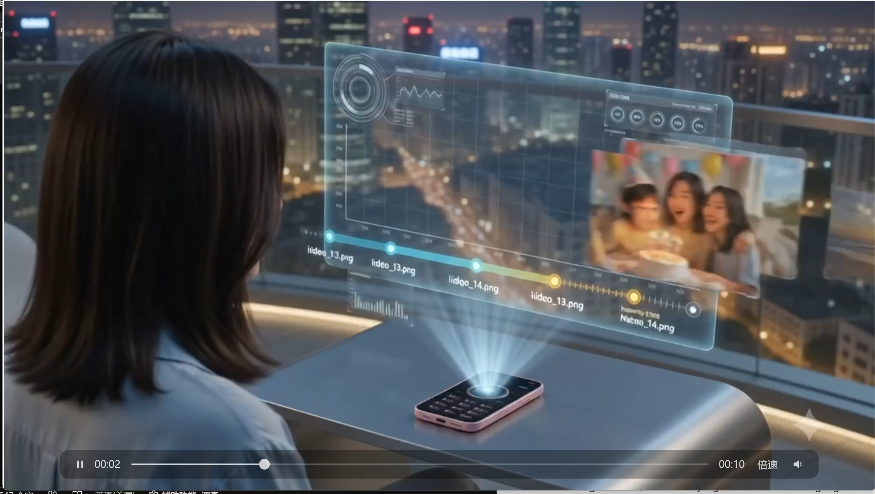
Futuristic smartphone AI automatically selecting and enhancing meaningful memories from daily life, holographic photo timeline floating in the air, emotionally significant moments highlighted naturally, cinematic and emotional atmosphere
“未来感智能手机的 AI 自动从日常生活中筛选并增强有意义的回忆，悬浮在空中的全息照片时间轴，自然地突出那些具有情感意义的重要瞬间，整体呈现电影感且富有情绪张力的氛围。”
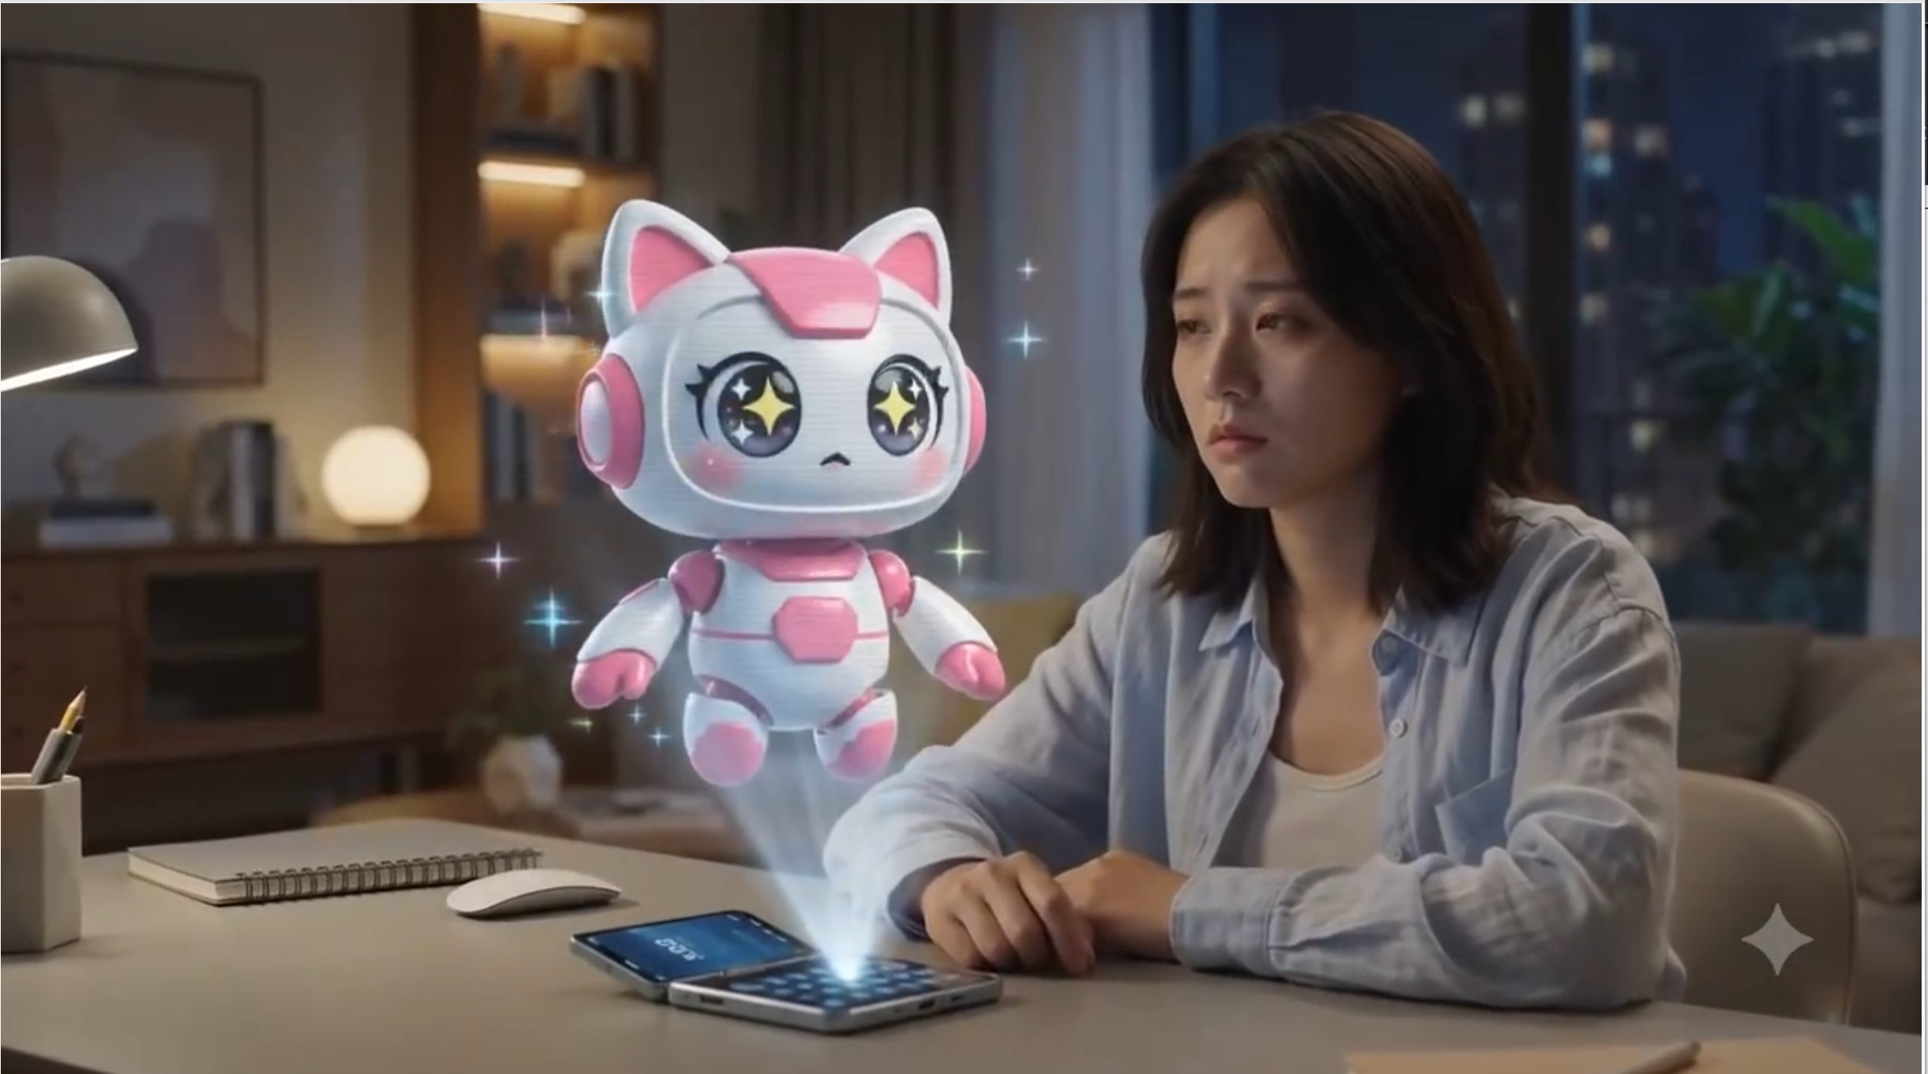
Cute holographic AI companion appearing softly beside the user, emotionally supportive futuristic assistant, warm ambient lighting, comforting and human-centered atmosphere, advanced but believable future technology
“一个可爱的全息 AI 伙伴轻柔地出现在用户身旁，作为具有情感支持能力的未来助手；温暖柔和的环境光营造出安慰性、以人为中心的氛围；整体展现先进但可信的未来科技感。”
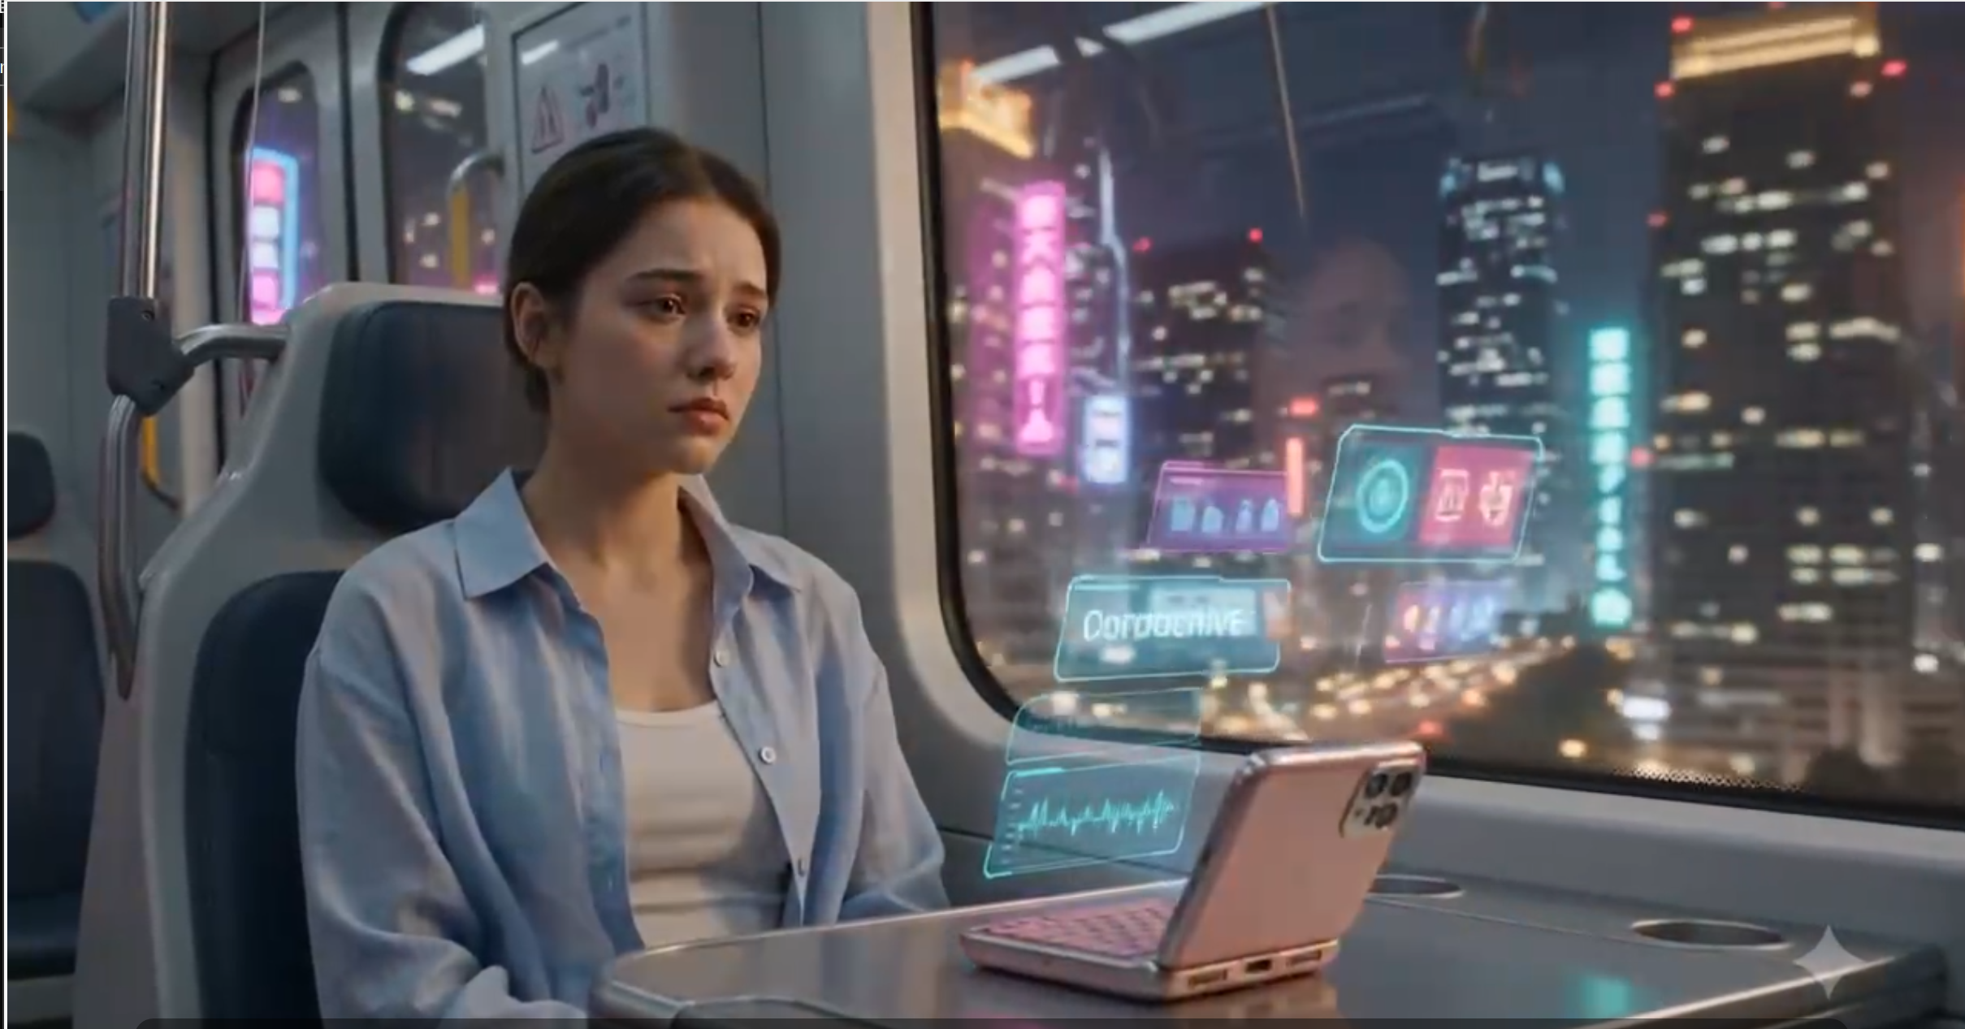
Young woman sitting quietly on futuristic public transport, city lights reflecting around her, AI camera automatically capturing cinematic emotional moments, subtle holographic framing suggestions appearing naturally, realistic emotional cinematography
“年轻女性安静地坐在未来感公共交通工具上，城市灯光在她周围映照闪烁，AI 相机自动捕捉富有电影感和情绪张力的瞬间，细微的全息构图建议自然地浮现出来，呈现真实而富有情感的电影式摄影效果。”
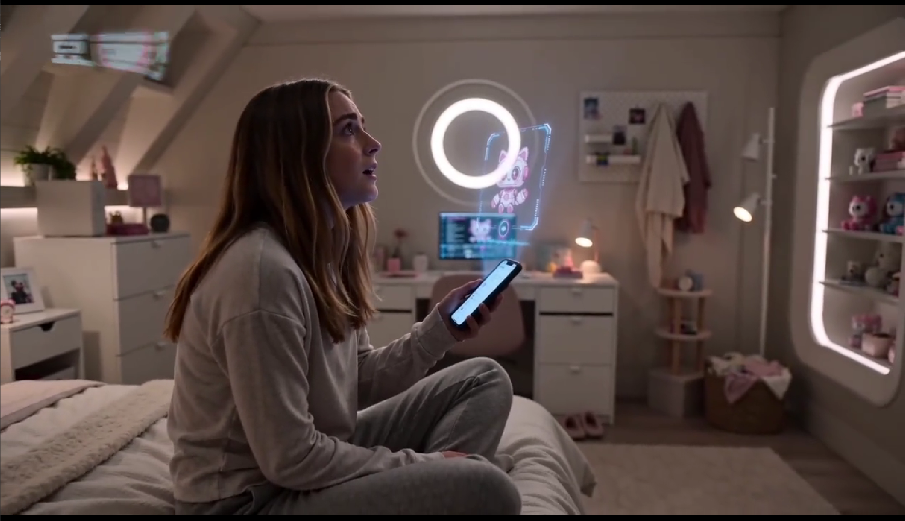
16:9 video emotionally cinematic futuristic bedroom at night, soft ambient lighting, a young woman sitting alone quietly speaking to a holographic AI assistant projected from her smartphone, emotional but comforting atmosphere, holographic interface listening attentively, warm futuristic environment, human-centered AI interaction, cinematic realism, subtle emotional expression”
“生成一段 16:9 的视频：夜晚充满情绪电影感的未来卧室场景，柔和的环境灯光，一位年轻女性独自安静地坐着，对着由智能手机投射出的全息 AI 助手轻声交谈；整体氛围带有情感但又令人感到安慰，全息界面专注地倾听着她，环境温暖且富有未来感，展现以人为中心的 AI 互动，电影感写实风格，人物情绪表达细腻而自然。”

